Date: 2-9-2025

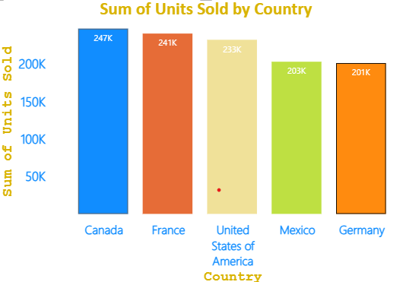

CT- Stacked column chart

Insights:

* Canada leads with the highest units sold at **247K**, closely followed by France (**241K**) and the United States (**233K**).
* The gap between the top three markets is relatively narrow, indicating strong and balanced sales performance across these regions.
* Mexico (**203K**) and Germany (**201K**) trail behind, contributing lower volumes.
* There is significant potential to strengthen sales in Mexico and Germany to bring them closer in line with the top-performing countries.

Steps to reproduce:

1. Selected Stacked column chart from build visuals.
2. Pass Country to x-axis and unit sold to y - axis. (You can check data type in table view for any column. For unit sold sum was selected and in report view while selecting y axis you can select any option according to the requirement. Here I have selected sum)

Note: Always pass character column to the first option in build visual. (i.e if x axis stands first pass country to x axis or passes to y axis.

Pass numerical column to left out axis.

1. Go to format your visual and change the values in x axis.

Options available are:

* Change font style
* Change font size
* Change font colour
* Turn value button on
* Then turn on the title. Change its font size,style and colour

1. In format your visual there is a option y axis.

Options available are :

Range

Value

Title

* Go to value and turn on the radio button
* Change font colour, style, size
* Turn on the title radio button, change font colour, style, size.

1. Go to gridlines.

* Turn of horizontal radio button off.

1. Go to column

* Select the category (column) and choose the colour

1. Turn on the boarder radio button
2. Turn on Data labels radio button

* Under option select the position

1. Turn on value radio button.

* Change font colour, style, size

1. In format visual go to General and turn on title radio button. Change font style, colour, size and alignment and save it.

**Bar and Column chart:**

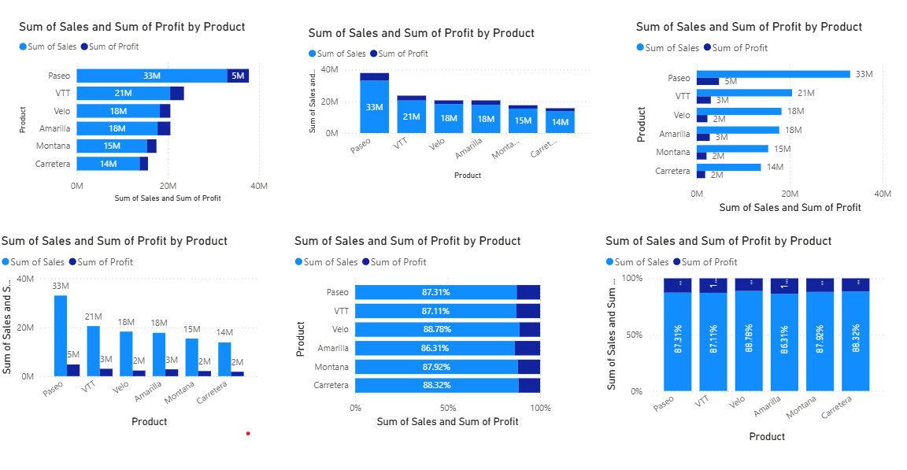

**Stacked bar chart:**

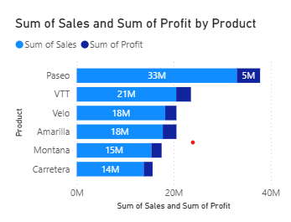

* What it shows: Horizontal version of stacked column chart.
* When to use: To compare part-to-whole relationships in a horizontal layout.
* Example: Employee count by department and gender (M/F stacked).

**Stacked Column chart:**

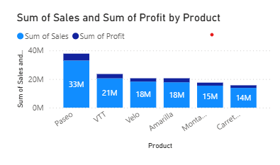

* What it shows: Vertical bars where subcategories are stacked on top of each other, representing a total.
* When to use: To see the total and also contribution of parts to the whole.
* Example: Total sales per year with a breakdown of sales by product type (TV, Laptop, Phone) stacked.

**Clusterd bar chart:**

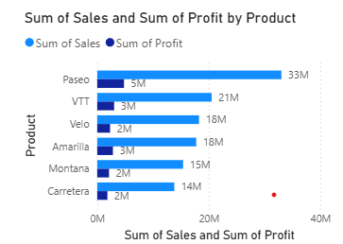

* What it shows: Similar to clustered column, but horizontal bars.
* When to use: Useful when category names are long, or when comparing across many categories.
* Example: Comparing population of different countries (country names are long, so bar chart looks cleaner).

**Clusterd Column chart:**

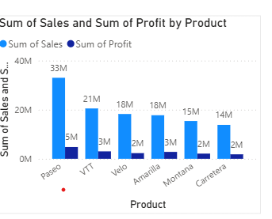

* What it shows: Compares values across categories using vertical bars side by side.
* When to use: To compare multiple series/categories across the same axis.
* Example: Sales of different product categories (Electronics, Clothing, Furniture) across different regions.

**100% stacked bar chart:**

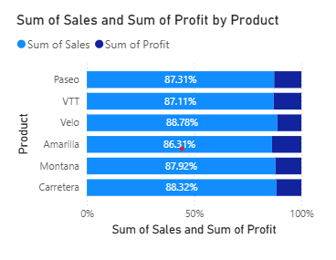

* What it shows: Horizontal version of 100% stacked column.
* When to use: To see percentage contribution with long category names.
* Example: % of budget spent on different expense types by department.

**100% stacked column chart:**

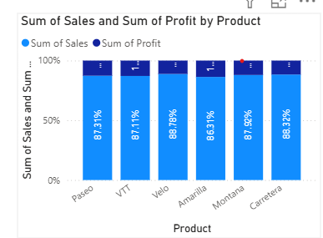

* What it shows: Each column represents 100%, with segments showing the percentage contribution.
* When to use: To analyze percentage contribution, not actual values.
* Example: Market share % of mobile brands (Apple, Samsung, OnePlus) per year.